Cordova Documentation

Author:

Farrukh Ahmed

Cordova Documentation

# **Introduction of Cordova:**

Previously PhoneGap is a software development **framework** by Adobe System, which is used to develop mobile applications. To develop apps using PhoneGap, the developer does not require to have knowledge of mobile programming language but only web-development languages like, HTML, CSS, and JScript.

PhoneGap is a distribution of Apache Cordova. So Apache Cordova serves as the engine to power PhoneGap just like WebKit – an engine that powers Chrome and Safari (iOS browser). Nonetheless, as an app developer or as an organization, you don’t have to worry about the differences between these two. The story is like this:

* PhoneGap was previously a product of Adobe.
* To keep it open-source always and follow standards, PhoneGap codebase was handed over to Apache.
* At Apache, it got a name change as Cordova.
* And now it’s better known as Apache Cordova.

# **Tools:**

* **Node.JS**
* **Java 8**
* **Android Studio (If deploy android app)**
* **PhoneGap Desktop (Optional)**
* **BlueStacks (Optional: An Android Emulator for run android app)**

# **Installation:**

1. Download Node.JS from <https://nodejs.org/en/download/> and Install using default settings.
2. Install the cordova module using npm utility of Node.js. With Windows CLI use this command:

C:\>npm install -g cordova

1. Edit path in Environment variable and add “C:\Users\user_name\AppData\Roaming\npm” and save however it will automatically set when installing NodeJS but confirm.
2. **Optional Step: Download PhoneGap Desktop application from here** <https://phonegap.com/getstarted/> **and Install**using default settings**. Note: we prefer to command cordova application from CLI for better understanding.**
3. **If you want to build an Android Application then Download Android Studio from here** <https://developer.android.com/studio/index.html>**and install as follow:**
   1. **Open Android Studio Setup   
      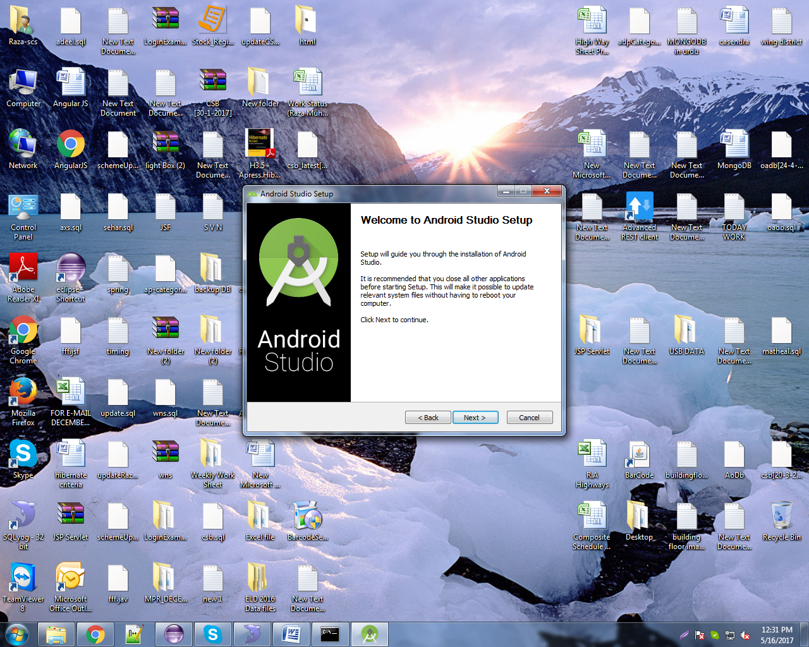**
   2. 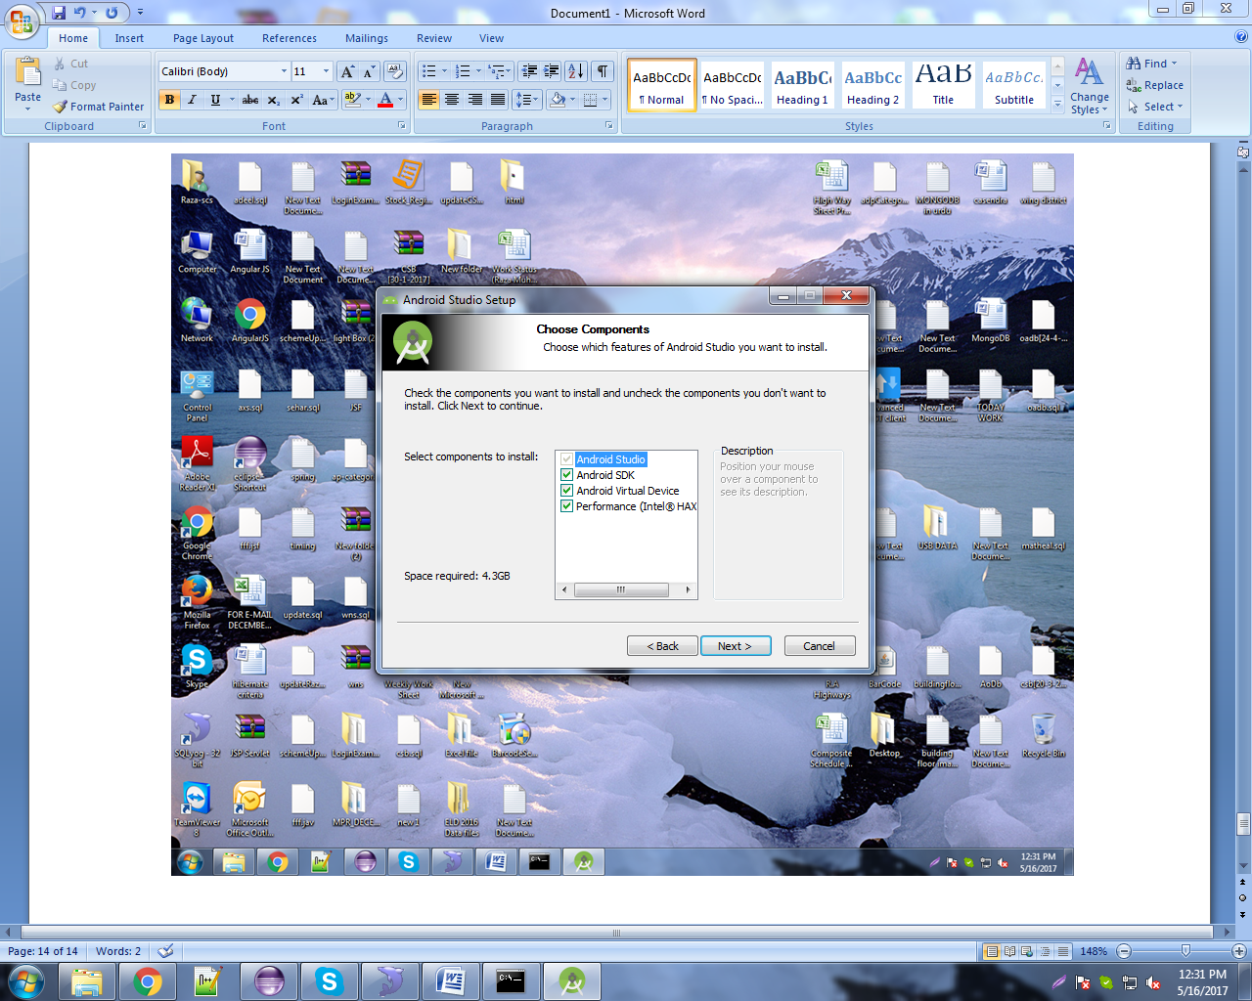
   3. 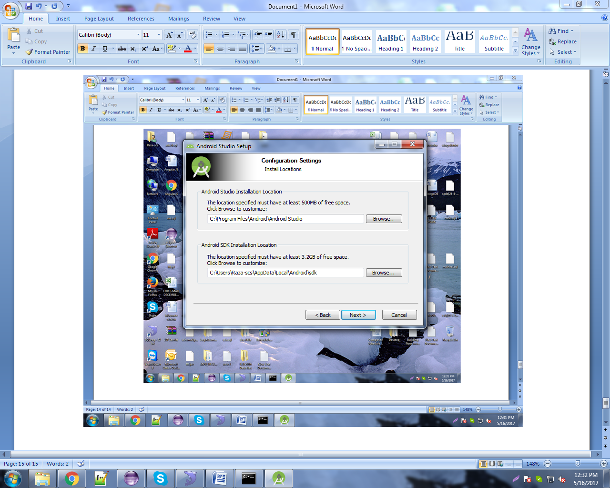

**If you already have SDK in your drive change path of Android SDK Installation location. Better not use C: Drive for SDK.**

* 1. 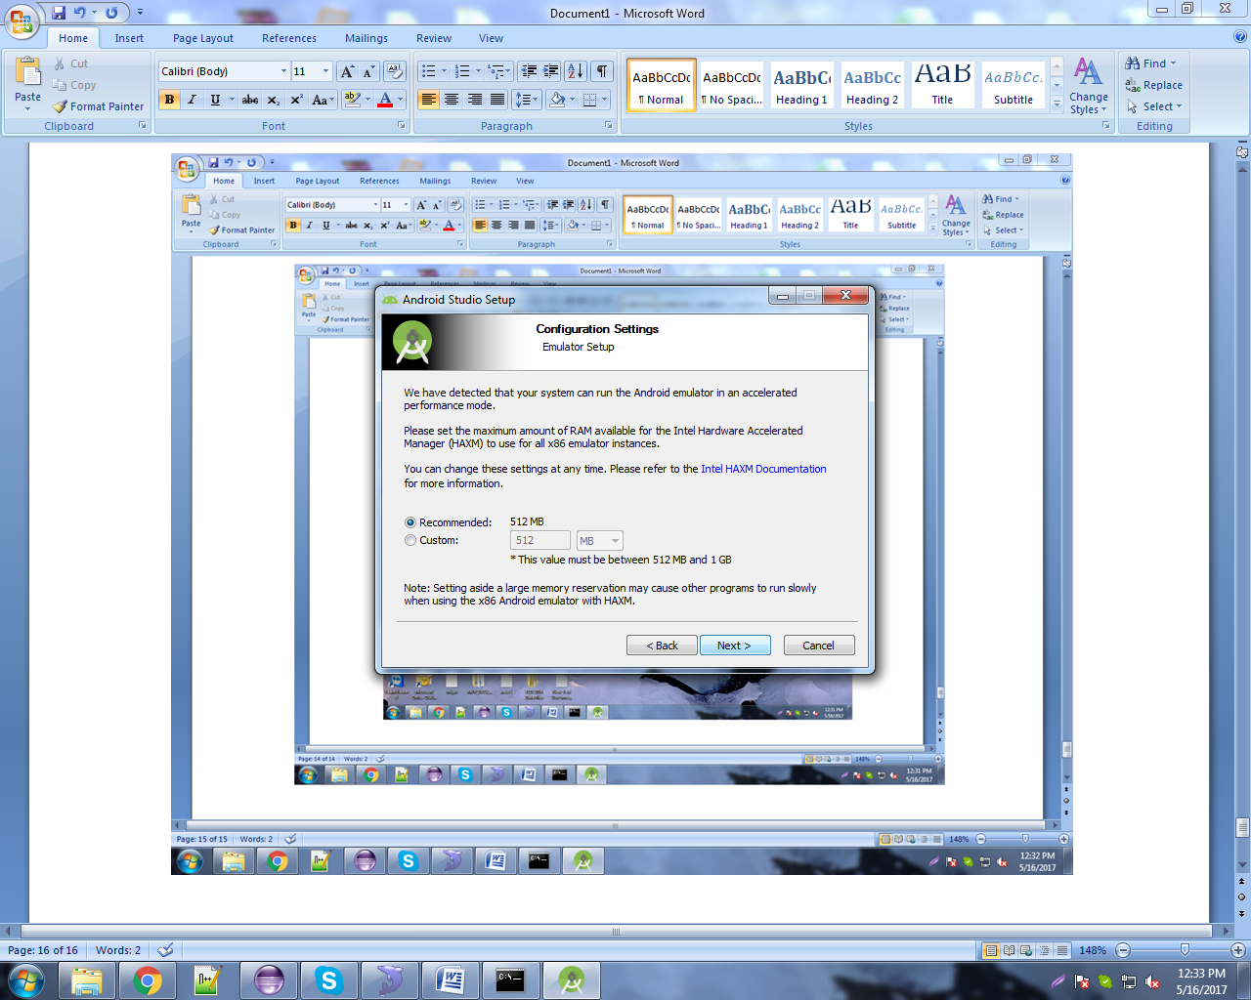
  2. 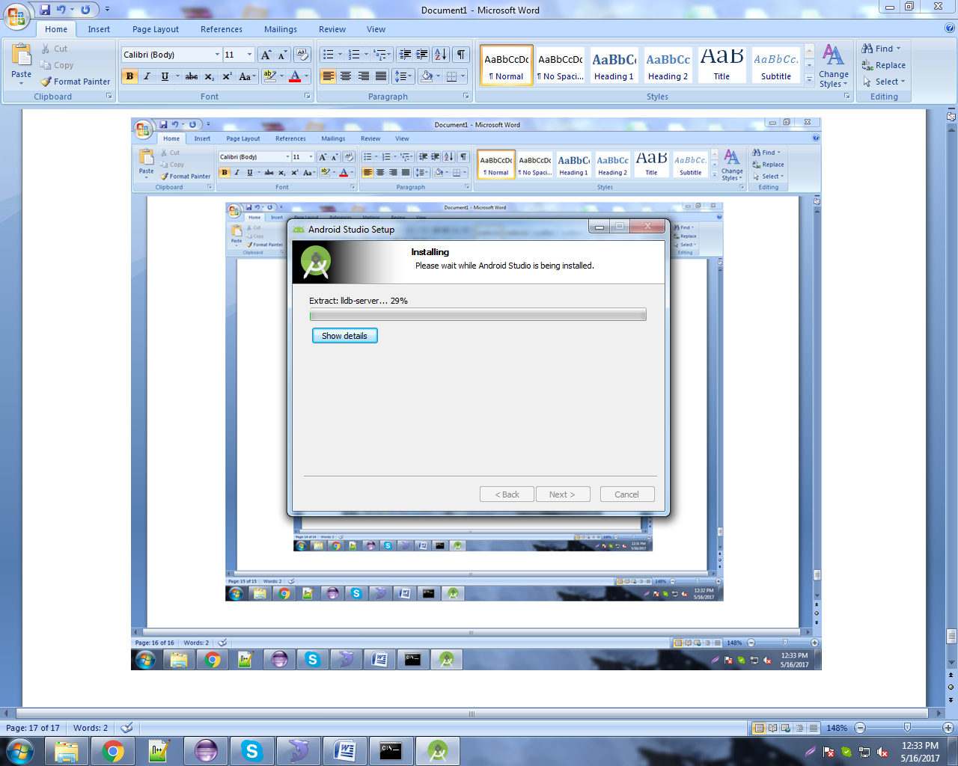
  3. **Select “I do not have previous version” than ok  
     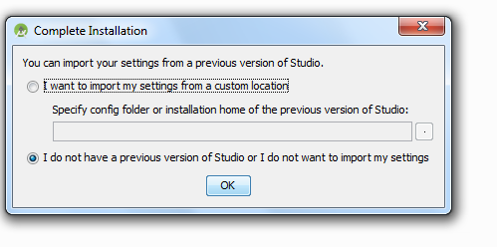**
  4. 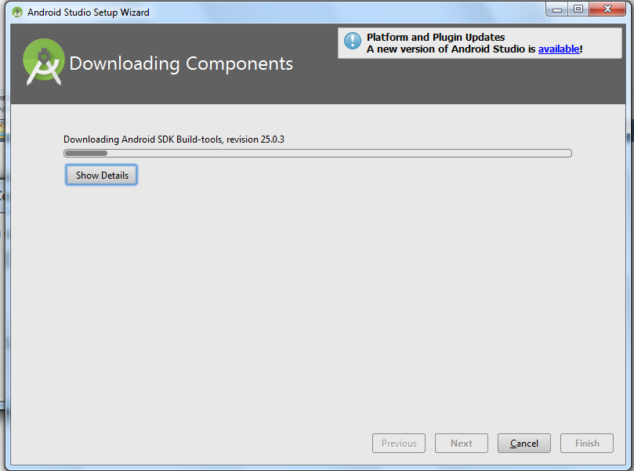
  5. **Finish.**
  6. **Open Installed Android Studio and click Configure than click SDK Manager**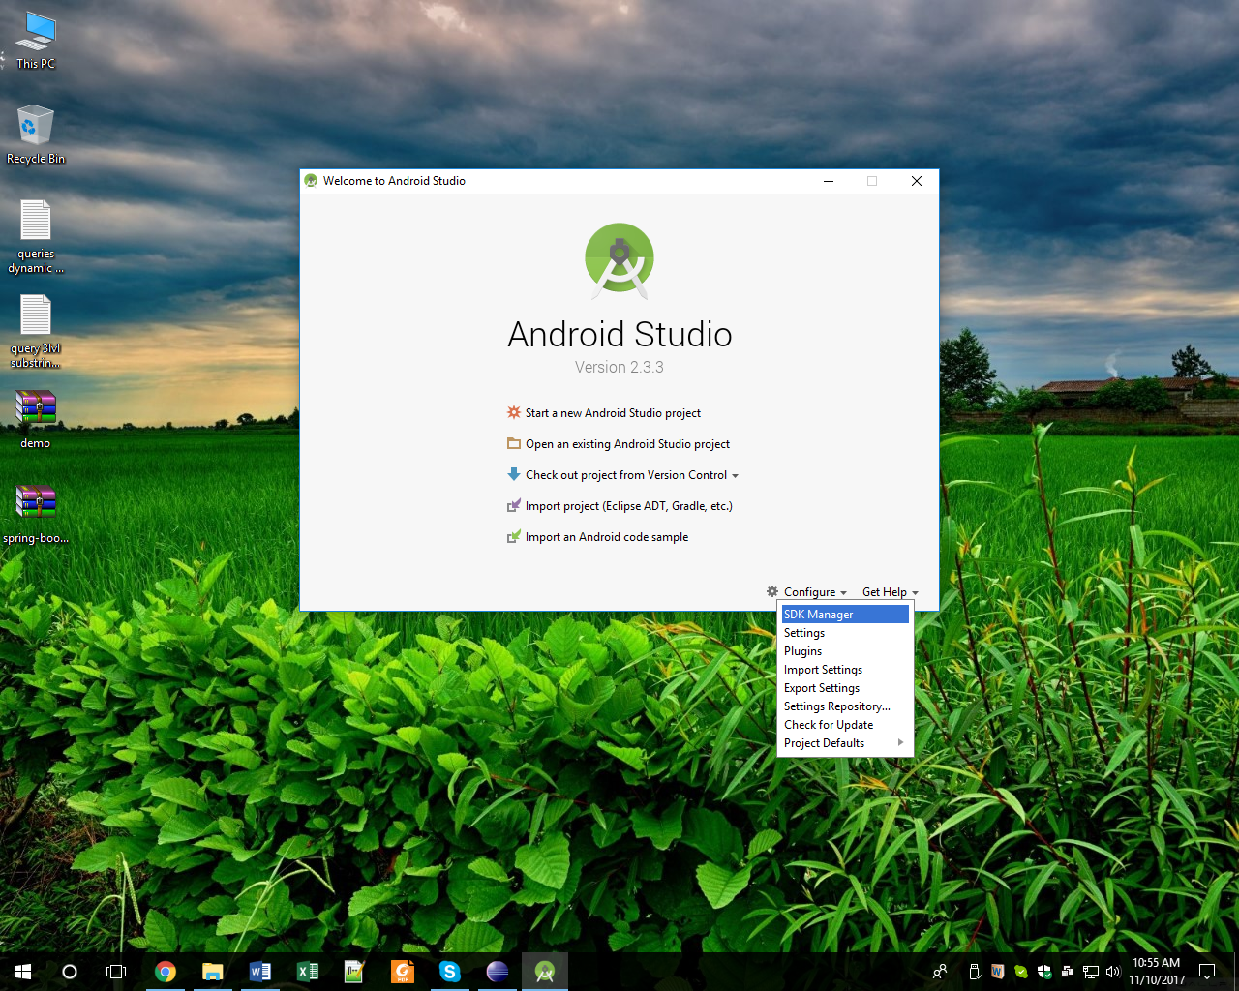
  7. **This will open Android SDK setting window. Check Android version SDK you want to install.**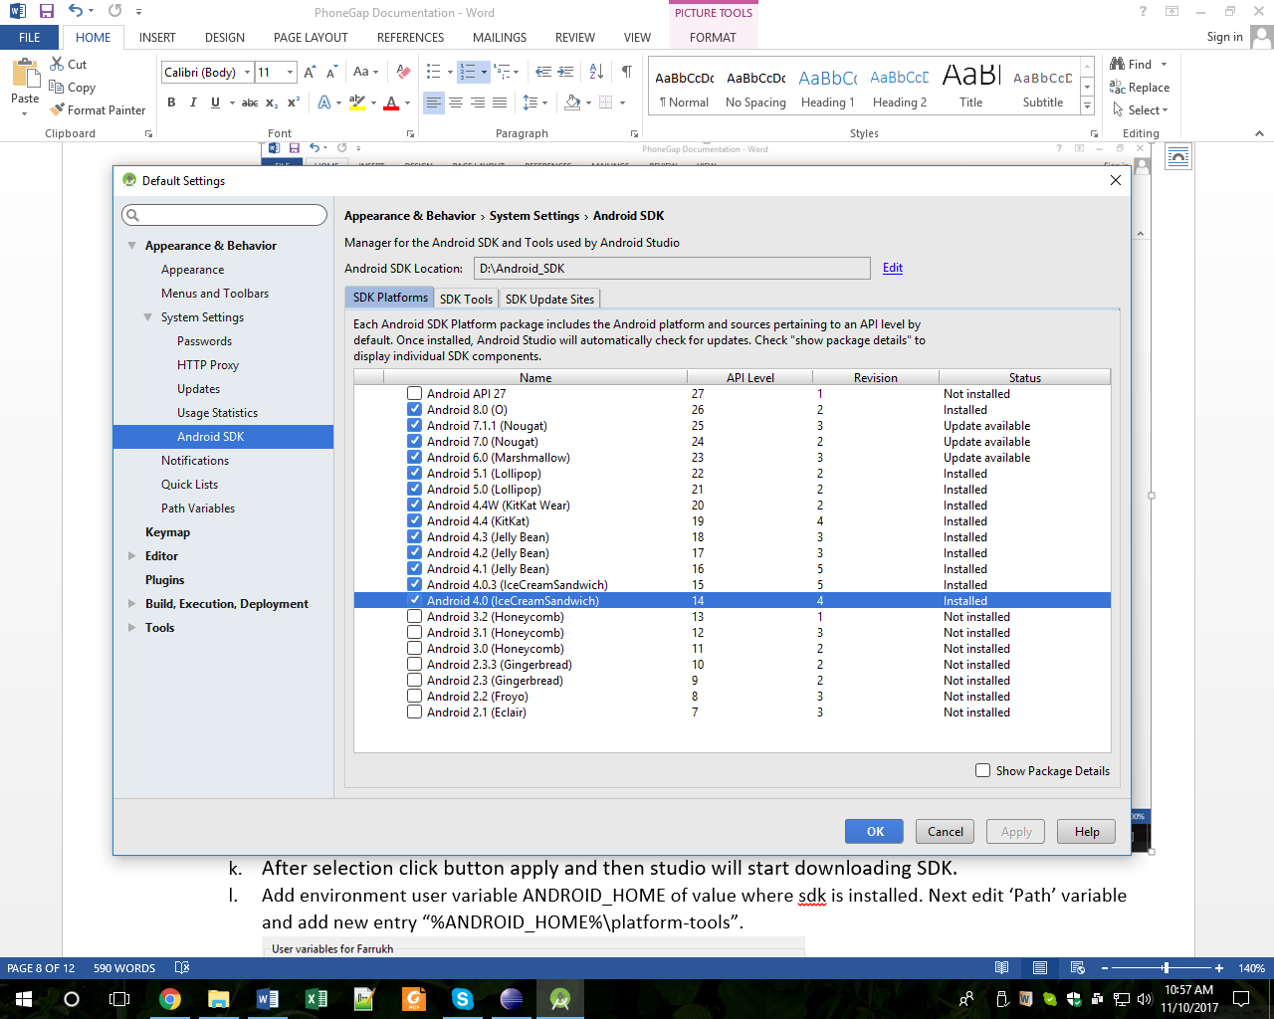

**And then check the following SDK Tools:**

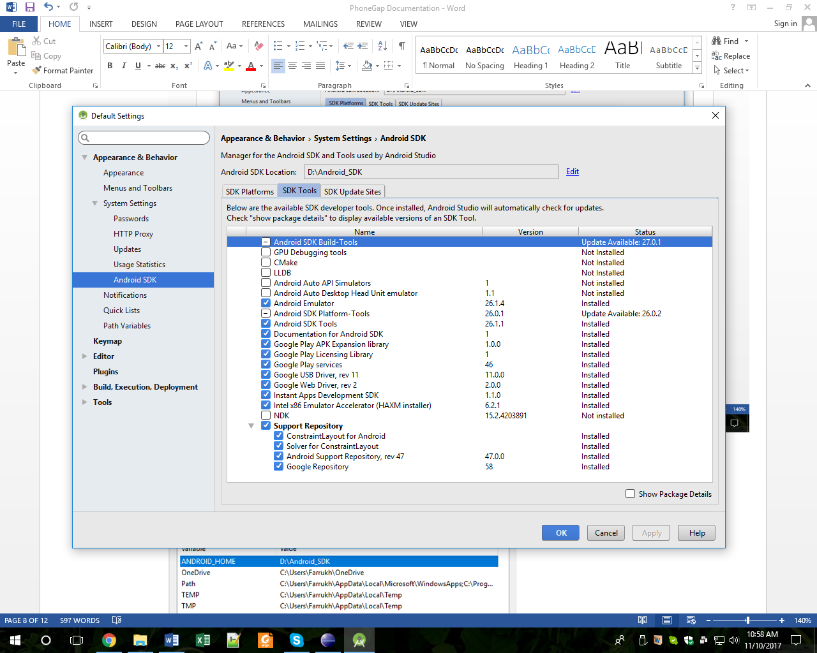

* 1. **After selection click button apply and then studio will start downloading SDK.**
  2. **Add environment user variable ANDROID_HOME of value where sdk is installed. Next edit ‘Path’ variable and add new entry “%ANDROID_HOME%\platform-tools”.**
  3. **Add environment user variable JAVA_HOME of value where jdk is installed.**

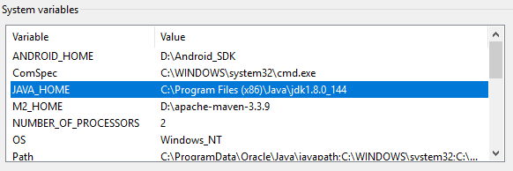

**Note: If you got that error when building android apk: Unable to start the daemon process:**

**Then add environment variable _JAVA_OPTIONS variable with value -Xmx512M**

# **Setup your first application and Run:**

**Go to the directory where you maintain your source code, and create a cordova project with CLI:**

cordova create hello com.example.hello HelloWorld

**Go to project location and run HelloWorld Application with command:**

cordova run browser

**browser platform will be added with cordova installation.**

**Or other way to create and run cordova project is to open PhoneGap Desktop Application and create new project by clicking plus sign. CMD is recommended.**

**NOTE: PhoneGap Desktop Application will download older versions of plug-ins that worked up tolimited new android version. For newer Android version support you should create project using the above CLI command.**

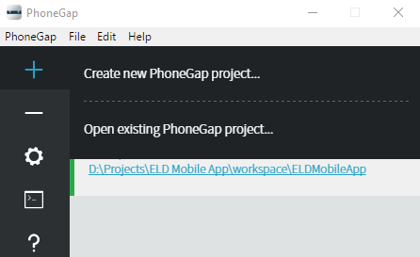

**After clicking create new PhoneGap project, select hello world Template and next select location where you want to create project, give project a name and then click create project button.**

**You can run this application in browser by click arrow button to run the server and then click the link given at footer of PhoneGap Desktop Application.**

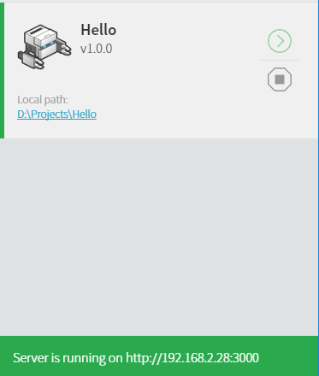

**Output:**

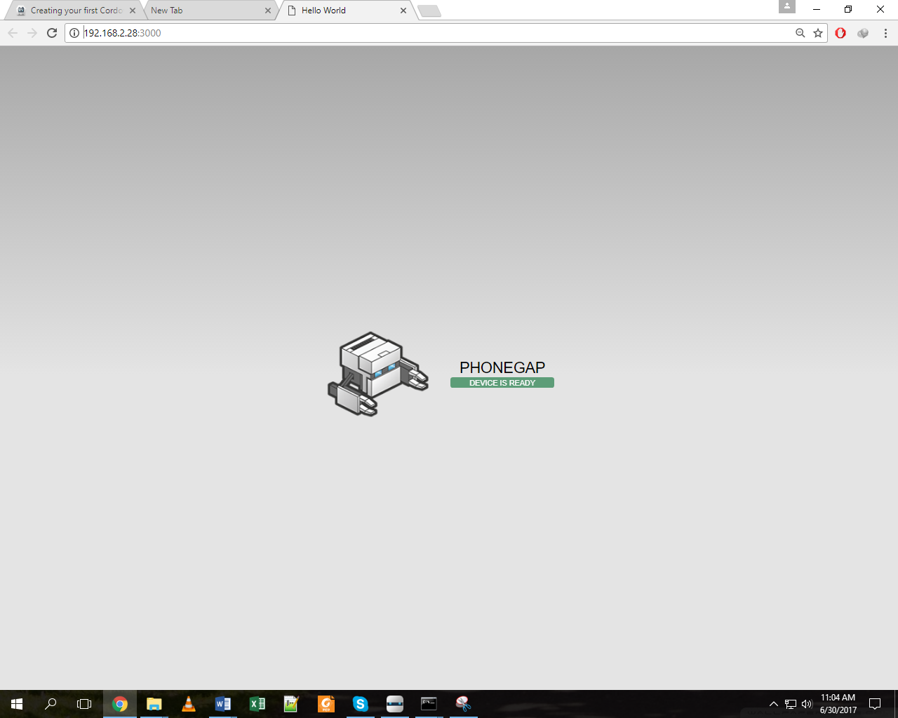

**To Deploy an Android App (.APK) file you need to go to location where project is created. CTRL + SHIFT + CLICK(Mouse) to open CLI at that location. After that write “cordova platform add android” and click enter. This will add android platform to your project.**

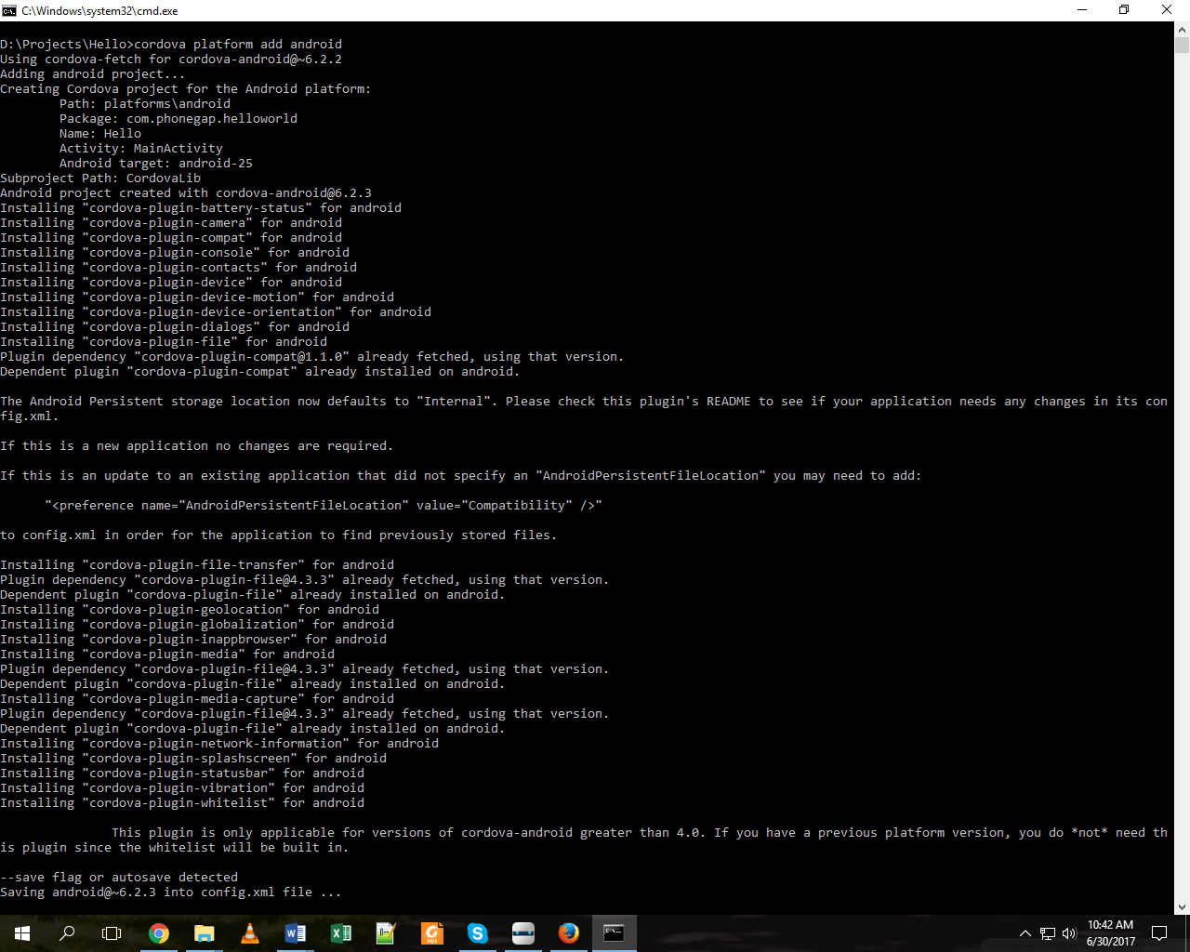

**After successfully complete adding platform, write ’cordova build android’. It will deploy apk file in \platforms\android\build\outputs\apk and download required files.**

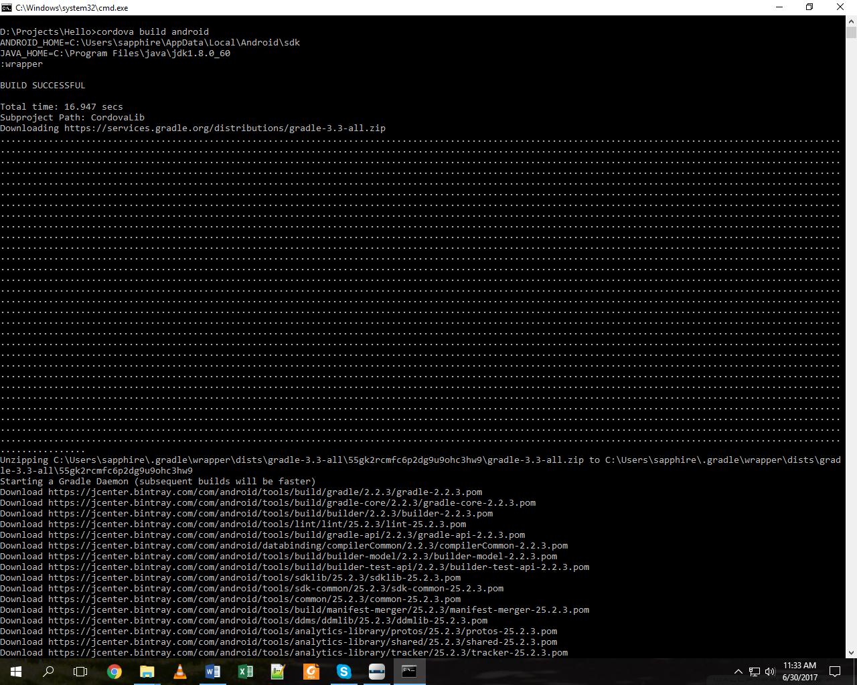 **To run your Android App you can install android emulator i.e.“Bluestacks” or use android device.**